Name: Robert McKinney

Assignment 3

Comments: I struggled a little bit with this week’s assignment – I’m not sure if I used the right kind of loop for Part 1, or if I created too many functions in Part 2, for example. Please let me know if I should have done them differently, and any critical feedback is welcome. Also, I made the font size of the code below 9 as opposed to 11 as some statements were too long and wrapped to the next line.

**Part I – python code**

# Robert McKinney

# Number game

import random # Import random module

number = random.randint(1, 20) # Initialize variable with a random integer between 1 and 20

numAttempts = 0 # Initialize counter

# Get user's name

name = input("Hello! What's your name? ")

print("Well,", name + "," " I'm thinking of an integer between 1 and 20.")

# Main loop

while numAttempts < 3:

guess = int(input("Take a guess. "))

numAttempts = numAttempts + 1 ## Increment counter

if guess < number:

print("Your guess is too low." )

if guess > number:

print("Your guess is too high. ")

if guess == number:

break

if guess == number:

print("Good job,", name + "! You guessed my number in", numAttempts, "guesses!")

if guess != number:

print("Sorry, your three guesses are over. The number I was thinking of was", number)

**Part I – screen shot of sample run**

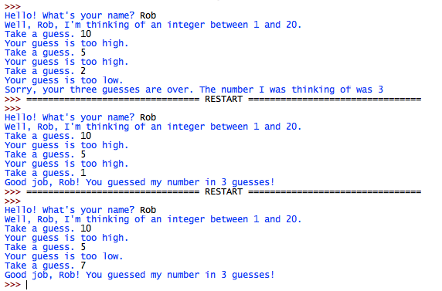

**Part II – python code**

# Robert McKinney

# Rock paper scissors game

# -----------------

# Define functions

# -----------------

def player_one_choice():

"""Get rock, paper or scissors from p1, and return choice as number 1 through 3"""

choice = input("Player 1: Please enter either (R)ock, (P)aper, or (S)cissors: ").lower()

if choice == "r":

return 1

elif choice == "p":

return 2

elif choice == "s":

return 3

def player_two_choice():

"""Get rock, paper or scissors from p2, and return choice as number 1 through 3"""

choice = input("Player 2: Please enter either (R)ock, (P)aper, or (S)cissors: ").lower()

if choice == "r":

return 1

elif choice == "p":

return 2

elif choice == "s":

return 3

def determine_winner(player_one, player_two):

""" Compare choices between players, calculate winner and return result"""

# Return 1 if player one wins, 2 if player two wins, and 0 for a tie

if player_one == 1 and player_two == 3:

return 1

elif player_one == 1 and player_two == 2:

return 2

elif player_one == 2 and player_two == 3:

return 2

elif player_one == 2 and player_two == 1:

return 1

elif player_one == 3 and player_two == 2:

return 1

elif player_one == 3 and player_two == 1:

return 2

else:

return 0

def print_results(winner):

"""Take returned value from determineWinner function and display result"""

if winner == 1:

print("Player 1 wins.")

elif winner == 2:

print("Player 2 wins.")

elif winner == 0:

print("There was a tie.")

# ----------

# Play game

# ----------

player_one = player_one_choice()

player_two = player_two_choice()

winner = determine_winner(player_one, player_two)

print_results(winner)

**Part II – screen shot of sample run**

